Name: Bagas Satrio Wicaksono
NIM: 254107020186

Experimental 1: Creating Class Diagram
Case Study 1:
In a company, one of the data that is processed is employee data. Each employee has an id, name, gender, title, title and salary. Each employee can also view personal data and see his salary.
Employee
+ Id: int
+ Name: string
+ Gender: string
+ Title: string
+ Salary: int
+ viewPersonalData(): void
+ seeSalary(): void
- Describe the class diagram design from case study 1!
The class diagram is a class named employee with 5 attributes and 2 methods
- Mention what classes can be made from case study 1!
Employee class
- Mention the attributes and data types that can be identified from each class from case study 1!
Employee class has 5 attributes, which are: id as int, name as string, gender as string, title as string, and salary as int
- Mention the methods that you created from each class in case study 1!
Exployee class has 2 methods, which are: viewPersonalData() and seeSalary()

Experimental 2: Create and accessing the member of a class
Case study 2:
Look at the class diagram below. Make a program based on the class diagram!
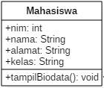
- Open the text editor/ IDE ex: Notepad ++ / netbeans.
- Write the code below:
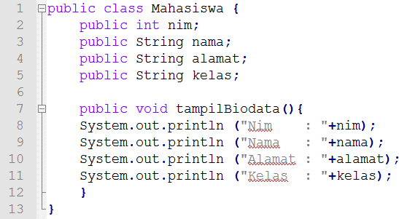
- Save it into Mahasiswa.java.
- To access the members of an object, the instance of the class must be created first. To show how to access the members of the Student class, let’s create a new file and then typing the following program code:
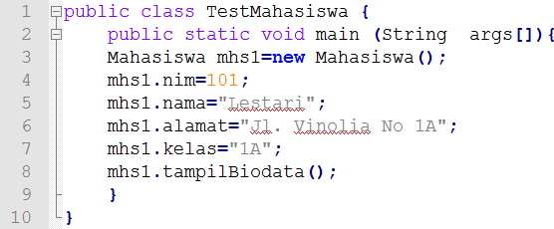
- Save it into TestMahasiswa.java
- Run the TestMahasiswa class
- Based on the code, please explain in which line the attribute declaration was?
in line 2 – 5
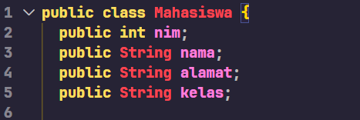
- Based on the code, please explain in which line the method declaration was?
line 7
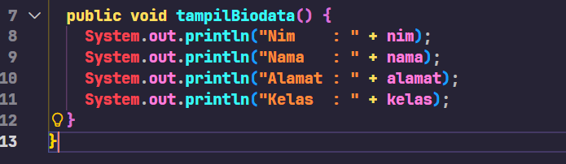
- How many objects instantiate from the code?
once
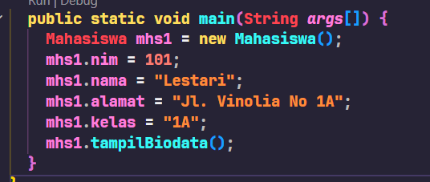
- What does this line “mhs1.nim=101” mean?
assigning the value 101 to the nim of the mhs1 object
- What does this line “mhs1.tampilBiodata()” do?
Running the tampilBiodata() method inside mhs1 object
- Please instantiate 2 more object, by adding more code!
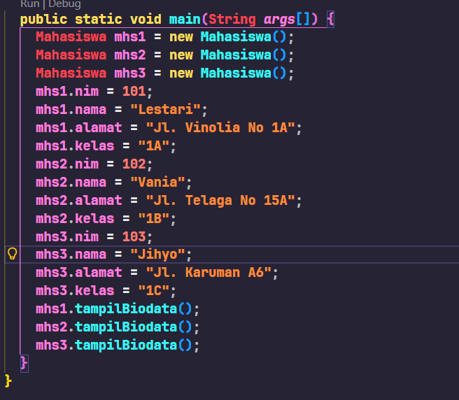
Here I added mhs2 and mhs3 object

Experimental 3: Writing method that has a return value
Scaffolding:
- Open the text editor/ IDE ex: Notepad ++ / netbeans.
- Write the code below:
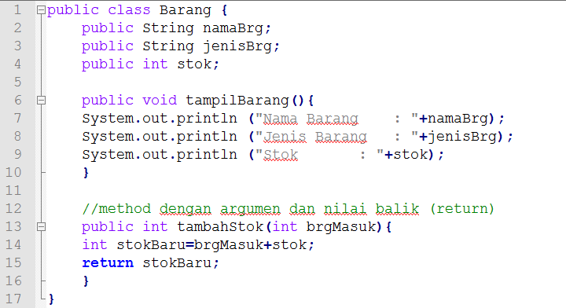
- Save into Barang.java
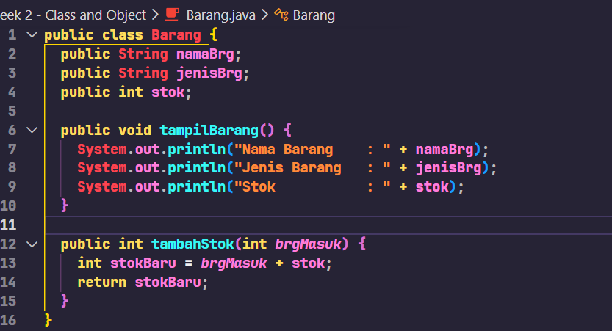
- To access the members of an object, the instance of the class must be created first. To show how to access the members of the barang class, let’s create a new file and then typing the following program code:
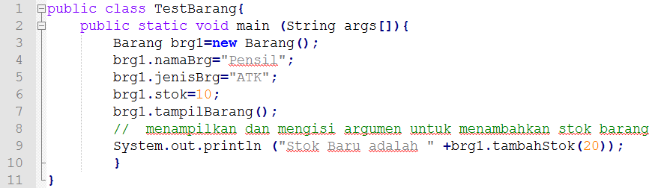
- Save intoTestBarang.java
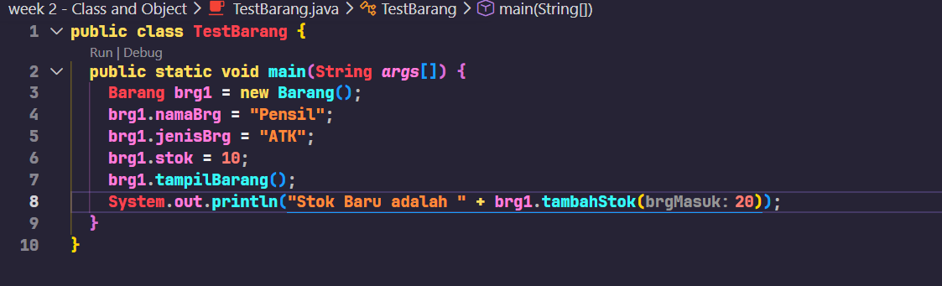
- Run the code!
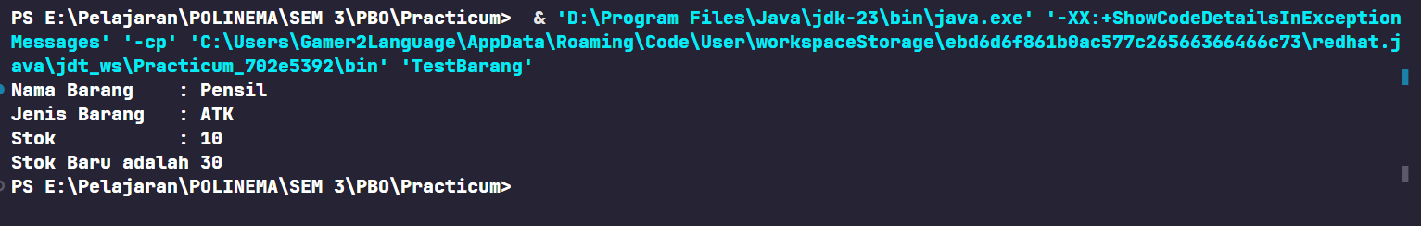
- What is the function of an argument in a method?
to pass a value to the method that we are calling
- Makes conclusion on “return” keyword, when should we used it?
we should use it when the method needs to return a value

4.2 Assignments
- One of the video game rental shops process is borrowing, The stored data when someone renting the game are the id, member name, game name, and the amount to pay. Each rent can display the data and the amount to pay. Make a class diagram based on the case study!
explanation:
  - The price amount will be coming from price per day times renting duration!
  - Assume that 1 transaction will only consist of 1 game.
Transaction
+ id: int
+ memberName: string
+ gameName: String
- pricePerDay: int
+ rentDuration: int
+ total: int
+ printInfo(): void
+ printTotal(): void
- Create the code based on the case study no 1!
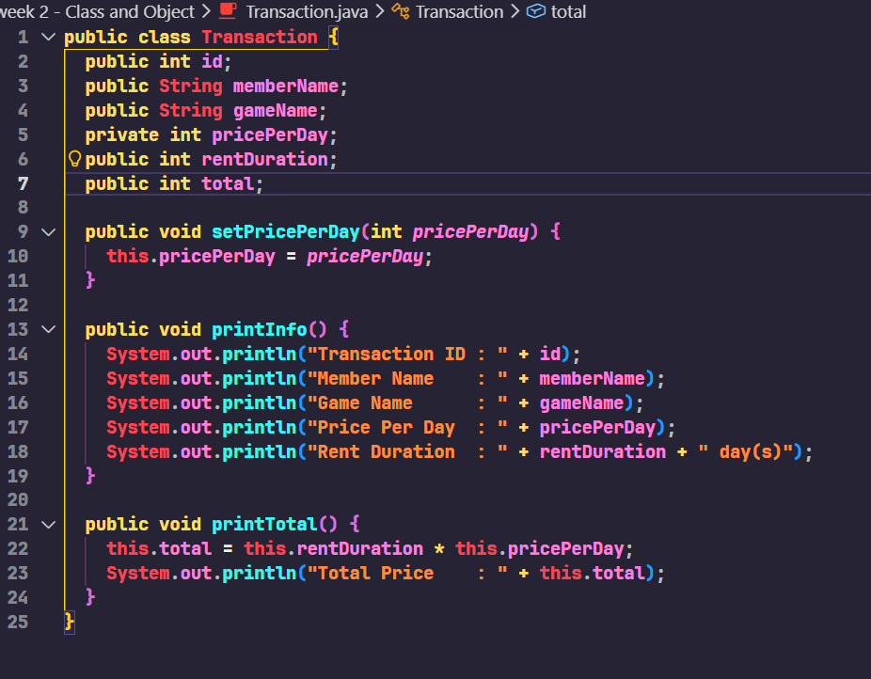
- More exercise, please create the code from the following class diagram:
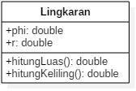
public class Lingkaran {
public double phi = 3.14;
public double r;

public double hitungLuas() {
return phi * r * r;
}

public double hitungKeliling() {
return 2 * phi * r;
}
}

- More exercise, please create the code from the following class diagram:
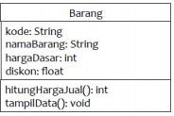
Description:
  - The hargaDasar attribute is in Rupiah and the discount atribute in percentage!
  - The hitungHargaJual() method used to calculate the based price by following this rule
Selling price (hargaJual)= base price(hargaDasar) – (discount(diskon) x base price (hargaDasar))
  - The tampilData() Method will be used to show the value of each class attribute:e kode, namaBarang, hargaDasar, diskon dan harga jual.
public class Barang {
public String kode;
public String namaBarang;
public int hargaDasar;
public float diskon;

public int hitungHargaJual() {
return (int) (hargaDasar - ((diskon / 100) * hargaDasar));
}

public void tampilData() {
System.out.println("Kode Barang : " + kode);
System.out.println("Nama Barang : " + namaBarang);
System.out.println("Harga Dasar : Rp " + hargaDasar);
System.out.println("Diskon : " + diskon + "%");
System.out.println("Harga Jual : Rp " + hitungHargaJual());
}
}

